**Topcoder - Re-Implement Terms Endpoints**

**Verification Guide**

# 

# Setup

The direct app docker is https://github.com/appirio-tech/tc-common-tutorials/tree/master/docker/direct-app

Please follow the above two urls to configure and setup the tc direct app docker.

For the challenge microservice, compile and start it as the previous deployment guide.

Then execute the following sql for the common_oltp database:

--add the ban for user

delete from user_terms_of_use_ban_xref;

delete from terms_of_use where terms_of_use_id=1111;

insert into terms_of_use values (1111, null, 5, current, current, 'banned for the user', null, 3);

insert into user_terms_of_use_ban_xref (user_id, terms_of_use_id, create_date) values(132458, 1111, current);

--add dependency terms for user

delete from terms_of_use_dependency;

delete from user_terms_of_use_xref where terms_of_use_id in (4444, 5555);

delete from terms_of_use where terms_of_use_id in (4444, 5555);

insert into terms_of_use values (4444, null, 5, current, current, 'test terms of use 4', null, 3);

insert into terms_of_use values (5555, null, 5, current, current, 'test terms of use 5', null, 3);

insert into terms_of_use_dependency values (4444, 5555);

--the term is not electronically agreeable

delete from terms_of_use where terms_of_use_id=6666;

insert into terms_of_use values (6666, null, 5, current, current, 'test terms of use', null, 2);

--doc sign template is missing

delete from terms_of_use where terms_of_use_id=8888;

insert into terms_of_use values (8888, null, 5, current, current, 'no sign template id', null, 4);

--test data for agree terms

delete from user_terms_of_use_xref where terms_of_use_id = 7777;

delete from terms_of_use where terms_of_use_id in (7777);

insert into terms_of_use values (7777, null, 5, current, current, 'test terms of use 7777', 'url 7777', 3);

delete from user_terms_of_use_xref where terms_of_use_id = 9999;

delete from terms_of_use where terms_of_use_id in (9999);

insert into terms_of_use values (9999, null, 5, current, current, 'test terms of use 9999', 'url 9999', 3);

delete from user_terms_of_use_xref where terms_of_use_id = 2222;

delete from terms_of_use_docusign_template_xref where terms_of_use_id=2222;

delete from terms_of_use where terms_of_use_id = 2222;

insert into terms_of_use values (2222, null, 5, current, current, 'test terms of use 2222', 'url 2222', 4);

insert into terms_of_use_docusign_template_xref values (2222, 1);

# Verify

Import the docs/terms-of-use.postman_collection.json

Agree terms of use

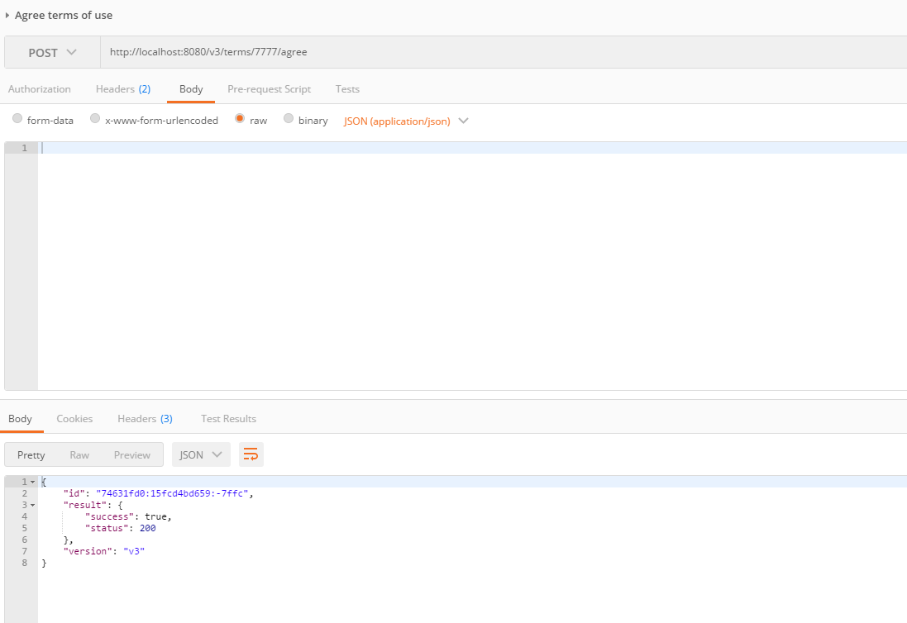

If agree it again, the error will be:

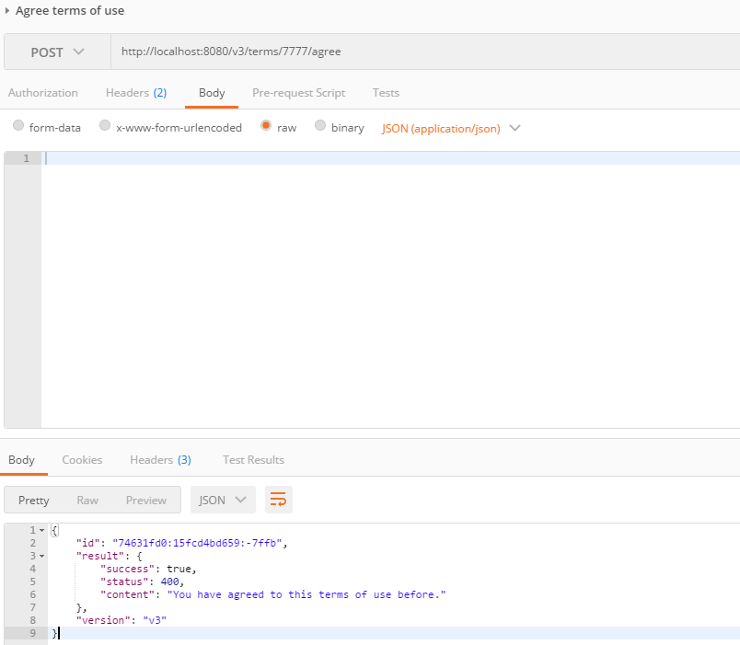

Agree terms of use (the term is not electronically agreeable)

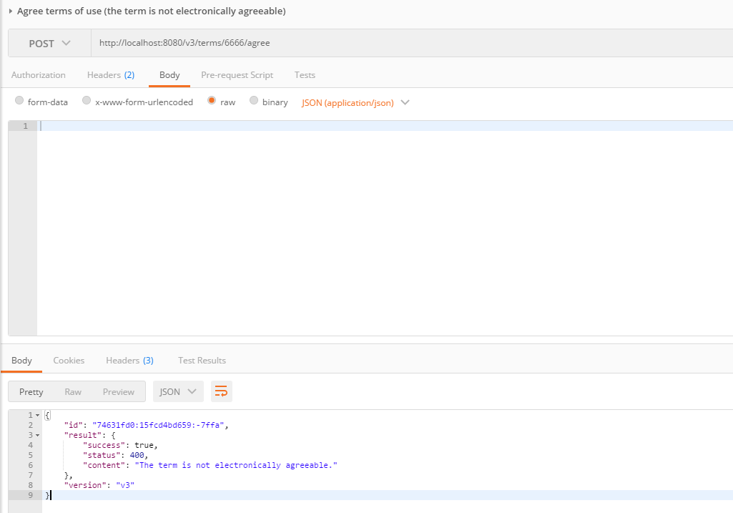

Agree terms of use (dependency terms not agreed)

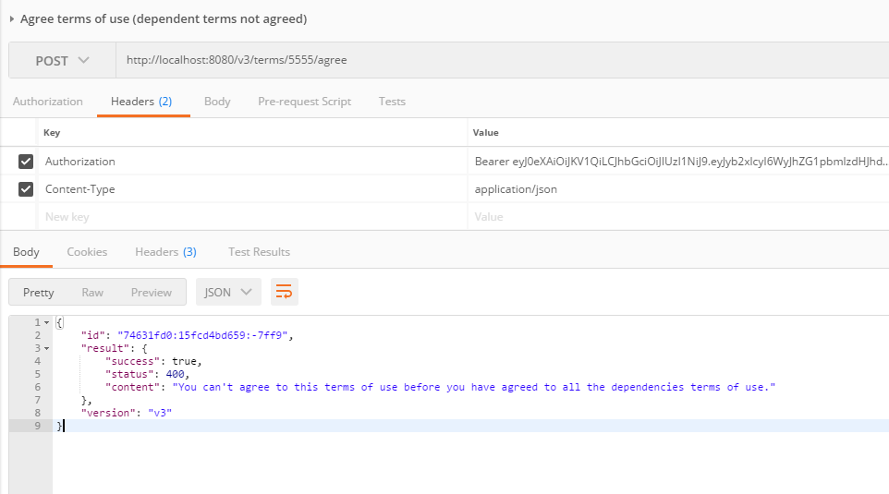

Agree terms of use (user banned for the terms of use)

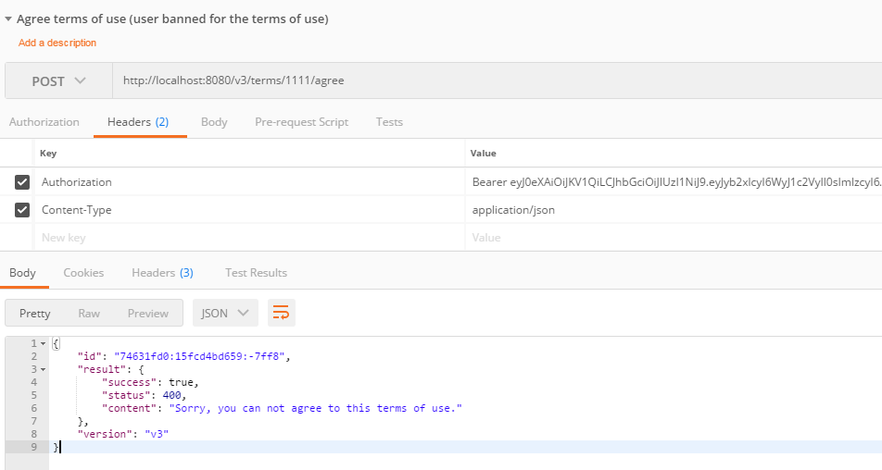

Agree terms of use (termsOfUse id not found)

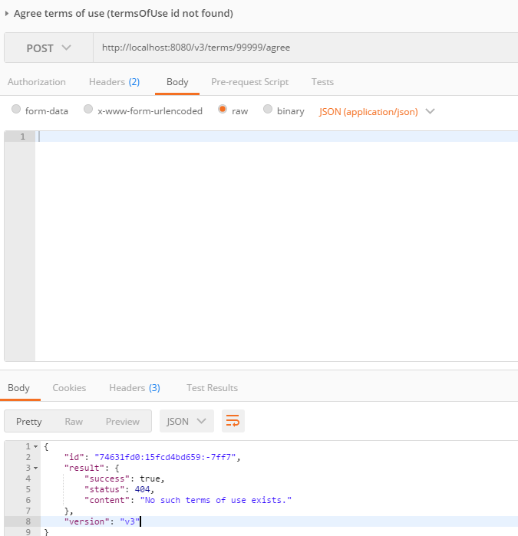

Get terms of use(aggreed)

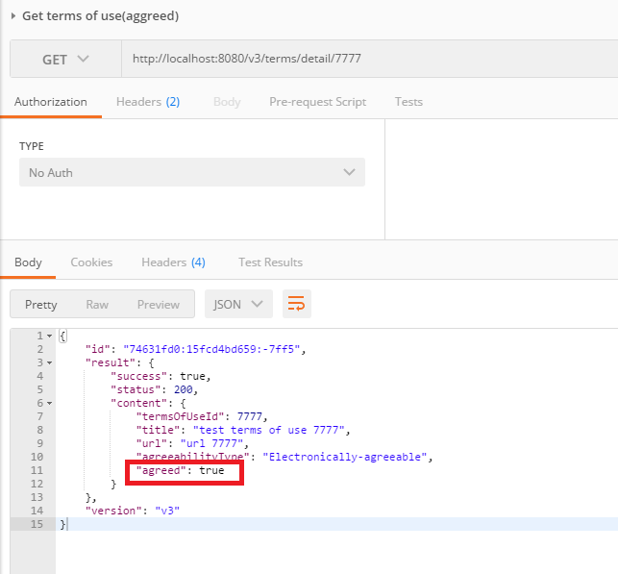

Run the following sql via JDBC or some other tools that can set the terms_text column:

update terms_of_use set terms_text = ? where terms_of_use_id in (7777, 9999, 2222)

The terms text can be any long text content.

Then check the api again, ther terms text will be showed:

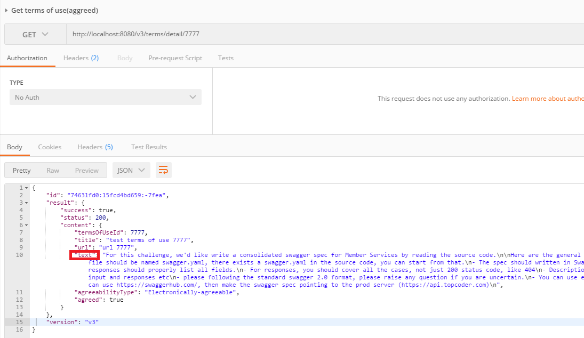

Get terms of use(not agreed)

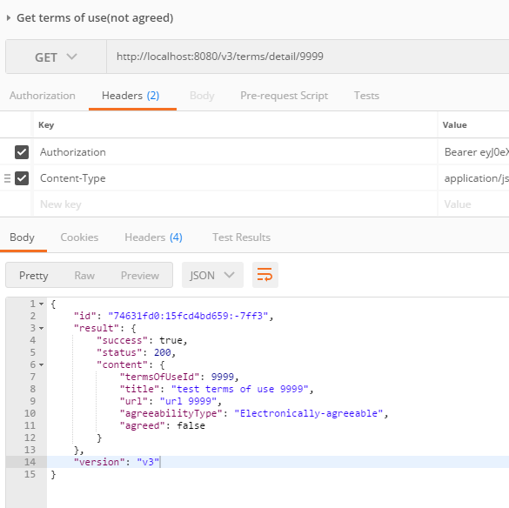

Get terms of use (for docusign template)

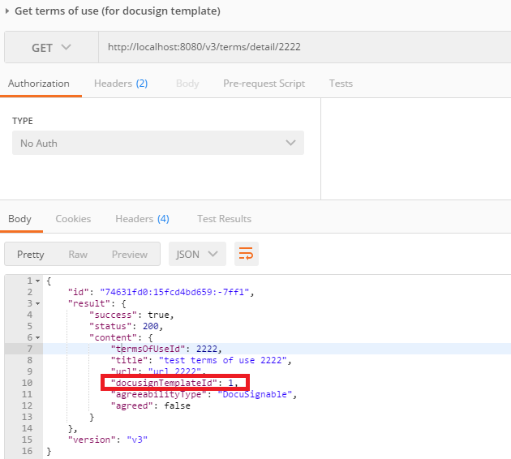

Get terms of use annoymous(noAuth=true)

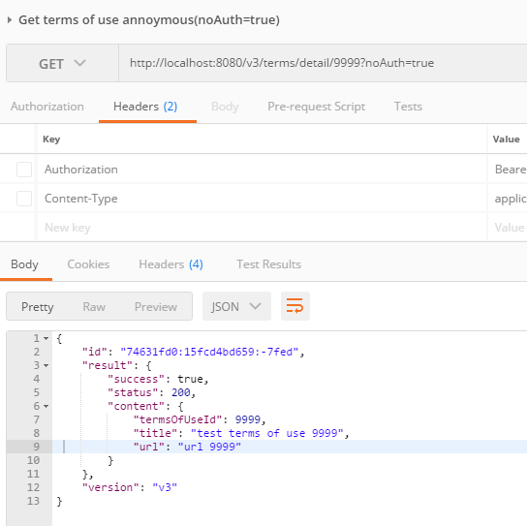

Get terms of use annoymous(noAuth=false)

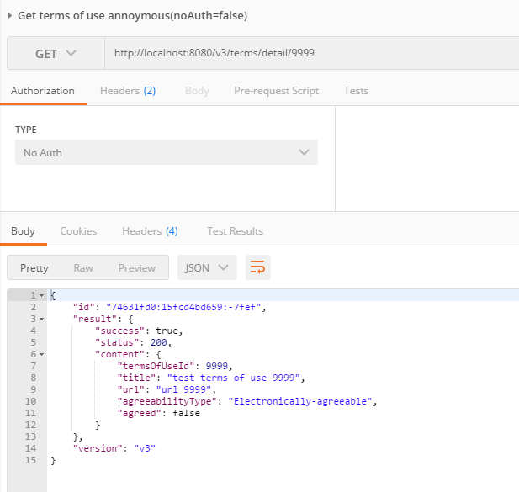

Get terms of use (docsign template id missing)

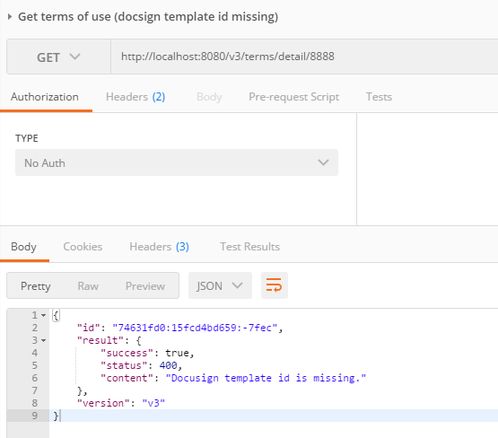

For the other apis, check them similar.